- Determination of voltage regulation of an alternator by synchronous impedance method and MMF method.
Exp No: Date :
Aim: To predetermine the percentage regulation of the given alternator by EMF (Synchronous Impedance Method) and MMF (Ampere Turns Method) by conducting OC and Short circuit test

Apparatus required:

S.no | Name of the Apparatus | Range | Type | Quantity
 | Ammeter | (0-2)A | MC | 1
 | Ammeter | (0-5)A | MI | 1
 | Volt meter | (0-600)V | MI | 2
 | Tachometer | (0-3000)rpm | Digital | 1
 | Rheostat | 1000 ohms/ 1.2 A | Wire wound | 1
 | Rheostat | 450 ohms/ 5A | Wire wound | 1
 | SPST switches | -- | Iron clad | 2
 | Connecting wires | 2.5sq.mm | Copper /Aluminum | Few

Name plate details:
Alternator
Rated power =
Rated voltage=
Rated current =
Rated speed=

DC Motor
Rated power =
Rated voltage=
Rated current =
Rated speed=

Precautions:
1. DC shunt motor field rheostat should be in minimum resistance position to get minimum speed at the time of starting.
2. Alternator field rheostat should be in minimum position.
3. DPST and TPST switches should be in open position.

Procedure:
Open Circuit Test:
1. Connections are made as per the circuit diagram is obtained.
2. The DC supply is obtained from control panel.
3. Observing the precautions, DPST switch on motor side is closed.
4. Using 3-point starter, the DC motor is started.
5. Vary the field rheostat of DC shunt motor to achieve the rated speed of the dc motor and hence alternator.
6. DPST switch in alternator field circuit is closed.
7. Keeping the TPST switch of alternator side open, the field current is varied using the alternator potential divider.
8. For various values of alternator field current (If), the generated AC line voltage (E_{OL}) is noted down and the readings are tabulated. (This should be done upto125% of rated voltage).

Short Circuit Test:
1. TPST switch on alternator side is closed.
2. By slowly increasing potential divider from minimum potential position, the values of If and corresponding Isc values are noted till rated current flows through the alternator.
3. The readings are tabulated.
4. Potential divider is adjusted to original position (minimum potential position) and field rheostat
on motor side is adjusted to minimum resistance position.
5. DPST and TPST switches are opened.
6. The supply is switched off.

Circuit diagram:

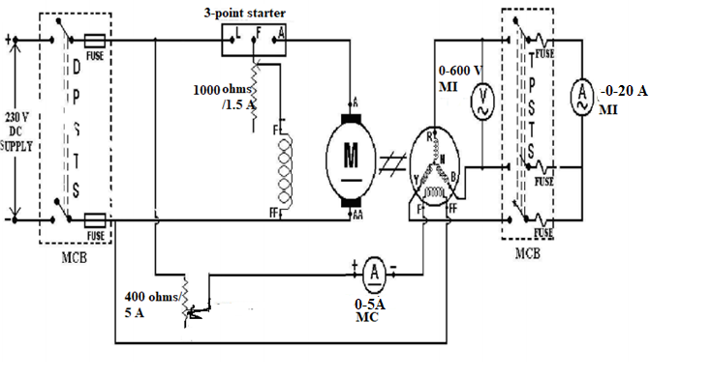

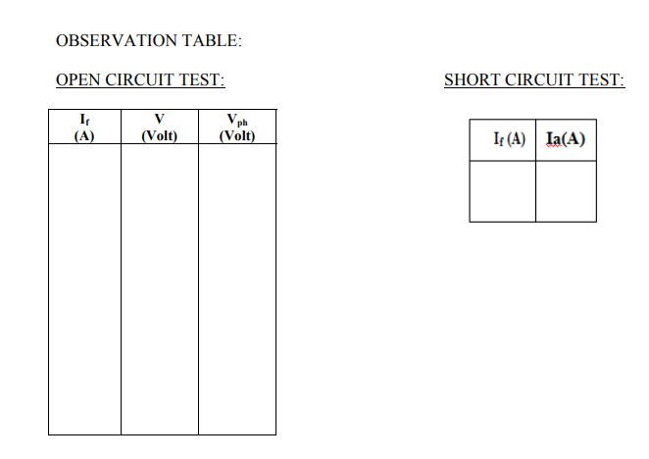
Data tabulation
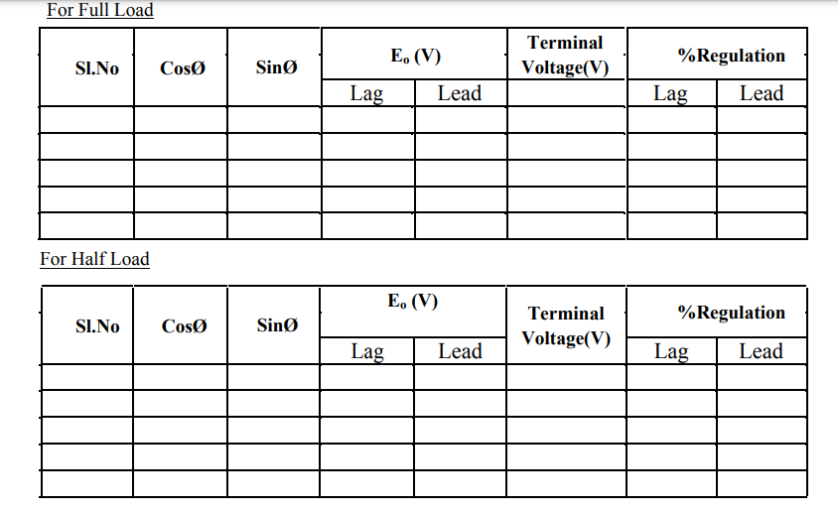

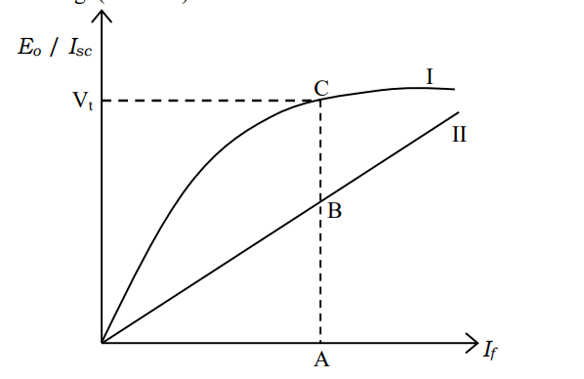
Plot of OCC and SCC curves

Formulae used:

EMF Method:
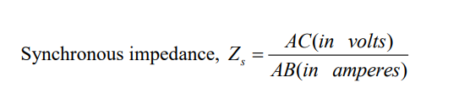
R_{a} will be given

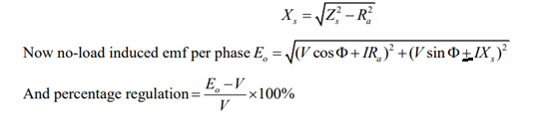

+ for lagging power factor
- for leading power factor

MMF Method:
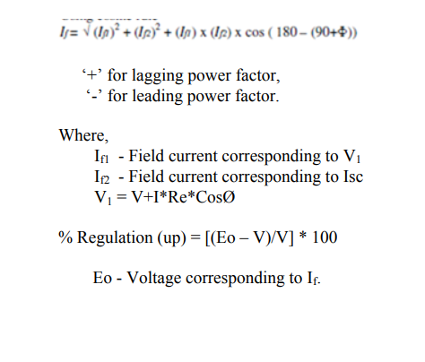

Result:

