- Speed control of 3-ph induction motor using MATLAB/ Simulink.
Exp No: Date :
Aim:
Speed Control of 3-∅ Induction Motor on MATLAB/Simulink Software.

Apparatus required:

MATLAB Simulink

Simulation Procedure:

- Open MATLAB Software and open blank Simulink page
- Create a model for 3-∅ Squirrel Cage Induction Motor.
- Select the appropriate elements and make the the MATLAB circuit diagram of the Model

Enter the rated value of the elements.

Select the reference voltage and observe the waveforms

Theory:

The speed control of induction motors is a crucial aspect in various industrial applications where precise control of motor speed is required. Induction motors are widely used due to their robustness and reliability. Controlling the speed of these motors allows for optimization of various processes, enhancing efficiency, and extending the motor's lifespan.
Principles of Induction Motor Operation:
Before delving into speed control methods, it is essential to understand the fundamental principles of induction motor operation. Induction motors operate based on electromagnetic induction, where a rotating magnetic field induces a voltage in the rotor, causing it to rotate. The synchronous speed of an induction motor is determined by the frequency of the power supply and the number of poles in the motor.
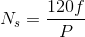
Speed of rotating magnetic field

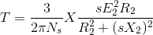
The torque equations of motor is given as

Speed of rotor is given by:-

Speed Control Methods:
Several methods are employed for controlling the speed of induction motors, catering to different applications and requirements. The primary speed control methods include:
1.Pole Changing: Changing the number of poles in the motor alters the synchronous speed. This method is achieved by reconnecting the stator windings to change the pole configuration.
2.Voltage Control: By varying the voltage supplied to the motor, the torque-speed characteristic can be adjusted. However, this method is limited in its effectiveness, especially at low speeds.
3. Frequency Control: Speed control can also be achieved by varying the frequency of the power supply. This method is commonly used in applications where precise speed control is essential.
Voltage/Frequency (V/F) control method is a widely used technique for controlling the speed of induction motors. In this method, both the voltage and frequency supplied to the motor are varied proportionally to maintain a constant V/F ratio. This ensures a consistent magnetic flux, allowing for smooth and efficient speed control. The V/F control method is commonly employed in various industrial applications where precise control over motor speed is essential.
Principles of V/F Control:
The basic principle behind V/F control is to maintain a constant ratio of voltage to frequency, often referred to as the V/F ratio. The synchronous speed (Ns) of an induction motor is directly proportional to the V/F ratio. Therefore, by adjusting the voltage and frequency simultaneously, the motor's speed can be controlled within a specific range.
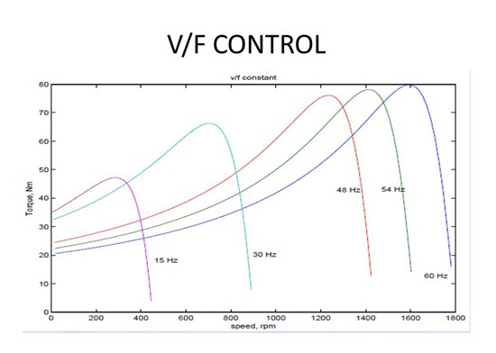

Simulink circuit:

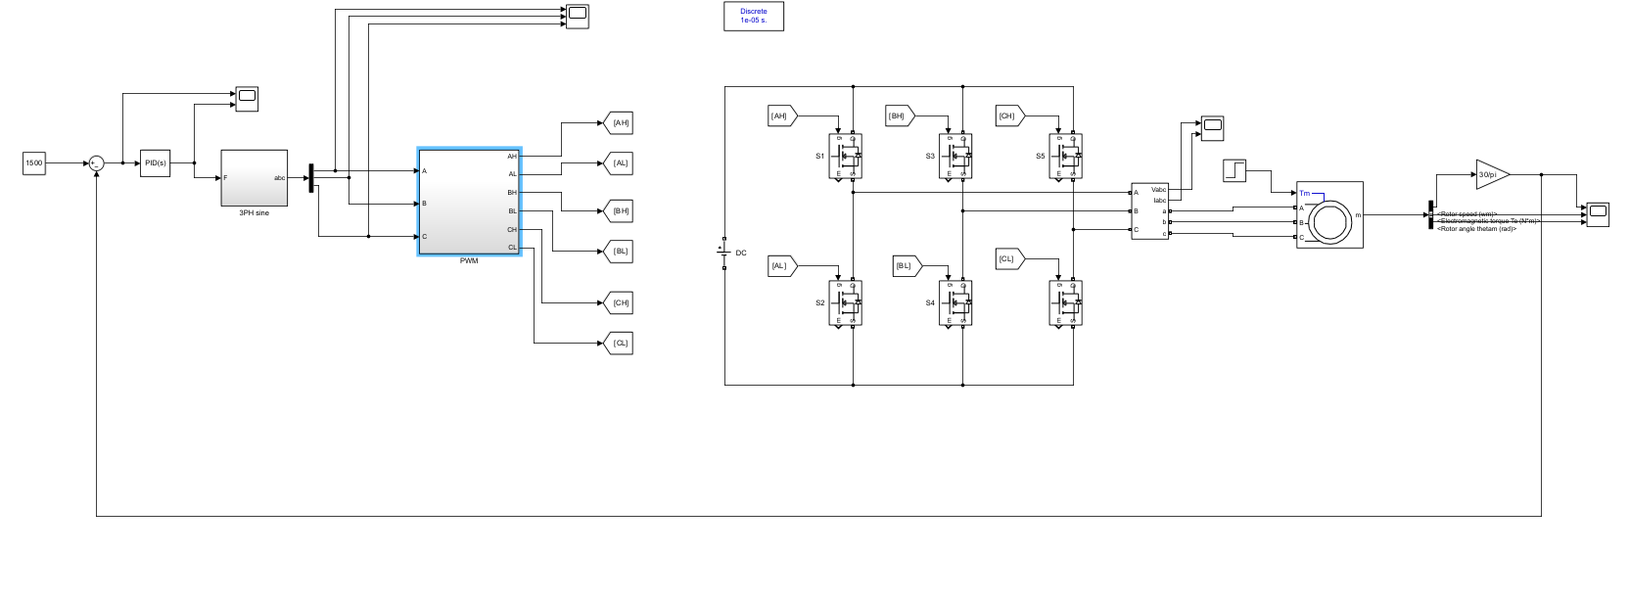

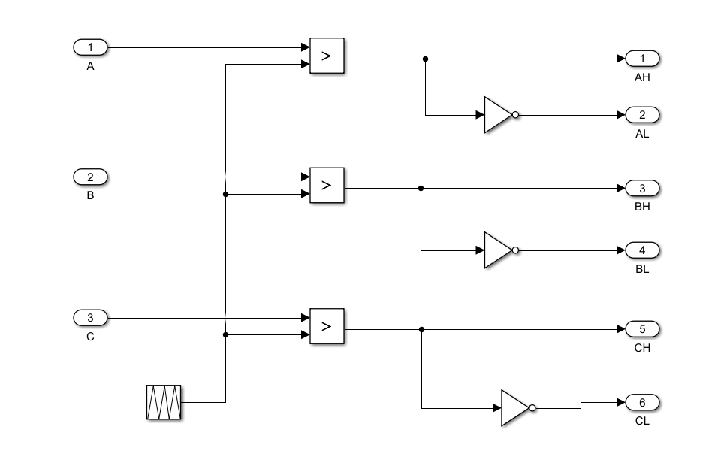

Fig 1. Speed Control of 3phase Induction Motor Using MATLAB

Observations:

S.No. | Input Voltage | Input Current | Electromagnetic Torque | Speed

Various Plotted Waveforms:

Result:

