2. Direct load test on a 3-Ø Alternator
Exp no: 2 Date

Aim: To conduct a direct load test on a 3-phase alternator and determine the efficiency.

Apparatus required:

S.no | Name of the Apparatus | Range | Type | Quantity
 | Ammeter | (0-5)A | MC | 1
 | Volt meter | (0-600)V | MI | 1
 | Ammeter | (0-20)A | MI | 1
 | Watt meter | 600 V,10 A | EDM type | 2
 | 3-ph resistive load | 5000 W | Wire wound | 1
 | Tachometer | (0-3000)rpm | Digital | 1
 | Connecting wires | 2.5sq.mm | Copper /Aluminum | Few

Name plate details:
Alternator
Rated power =
Rated voltage=
Rated current =
Rated speed=

DC Motor
Rated power =
Rated voltage=
Rated current =
Rated speed=

Precautions:
1. DC shunt motor field rheostat should be in minimum resistance position to get minimum speed at the time of starting.
2. Alternator field rheostat should be in minimum position.
3. DPST and TPST switches should be in open position.

Procedure:
1. Connections are made as per the circuit diagram is obtained.
2. The DC supply is obtained from control panel.
3. Observing the precautions, DPST switch on motor side is closed.
4. Using 3-point starter, the DC motor is started.
5. Vary the field rheostat of DC shunt motor to achieve the rated speed of the dc motor and hence alternator.
6. Vary the field excitation of the alternator to observe the rated voltage across the alternator.
7. Note down the readings of ammeter and voltmeter on dc motor side.
7. Note down the readings of ammeter and wattmeter for various loading conditions.
8. Cut out the load resistance and switch off the power supply.

Circuit diagram:

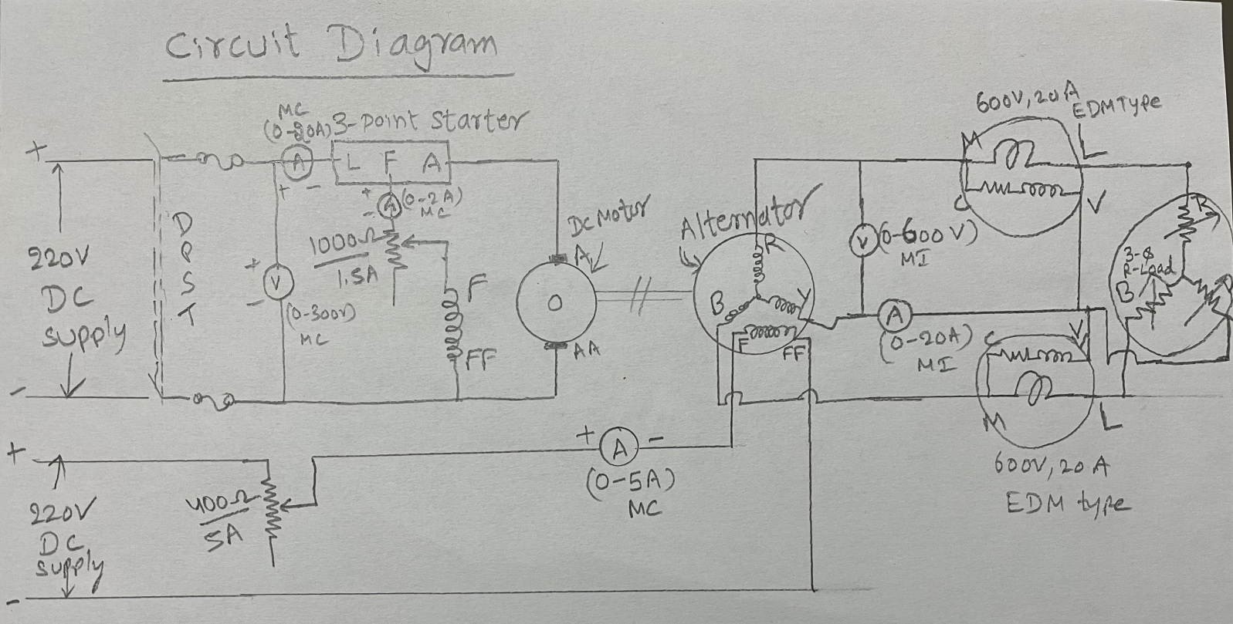

Observation Table

S.No | Vdc  (Volts) | Idc  (Amps) | Pin  Vdc* Idc | Ified  (Amps) | V_{Alternaor} (Volts) | I _{Alternator} (Amps ) | W1  (Watts) | W2  (Watts) | Pout  W1+W2  (Watts) | % Efficiency  (Pout/Pin)*100
1
2
3
4
5
6
7

Formulae used
Total Losses of the alternator Ploss = (Pin) Input power – (Pout) Output power= Copper losses + Core losses +Friction and windage losses +Load loss.
Result:

