3. Determination of V- curves and inverted V curves of a synchronous motor.
Exp no: Date

Aim: The aim of the experiment is to draw the V and inverted V curves of three phase synchronous motor.

Apparatus required:

S.no | Name of the Apparatus | Range | Type | Quantity
 | Ammeter | (0-10)A | MI | 1
 | Ammeter | (0-2) A | MC | 1
 | Volt meter | (0-600)V | MI | 1
 | Wattmeter | 600, 10 A | EDM type | 2
 | Tachometer | (0-3000)rpm | Digital | 1
 | Connecting wires | 2.5sq.mm | Copper /Aluminum | Few

Name plate details:
Synchronous motor
Rated power =
Rated voltage=
Rated current =
Rated speed=

DC Motor
Rated power =
Rated voltage=
Rated current =
Rated speed=

Precautions:

1. The potential divider should be in the maximum position.
2. The motor should be started without any load.
3. Initially TPST switch is in open position.

Procedure:
1. Note down the name plate details of motor.
2. Connections are given as per the circuit diagram.
3. Close the TPST switch.
4. By adjusting the auto transformer from minimum position to maximum position the rated supply is given to the motor. The motor starts as an induction motor.
5. In order to give the excitation to the field winding, close the DPST switch.
6. By varying the field current with the help of field rheostat from under excitation to over excitation, note down the armature current and the input power at no load, half load and full load conditions .
7. Later reduce the load and the motor is switched off after observing the precautions. Note down the readings of ammeters and voltmeter readings.

Circuit diagram:

Observation Tables:
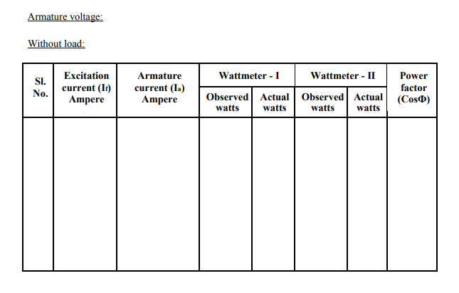

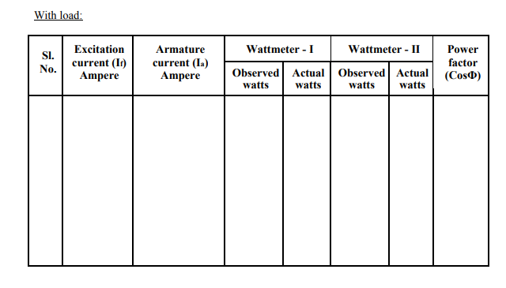
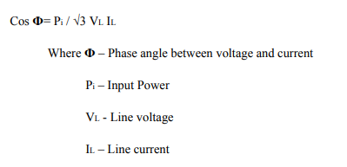
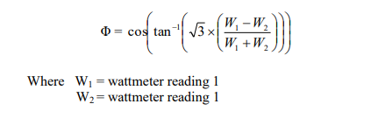
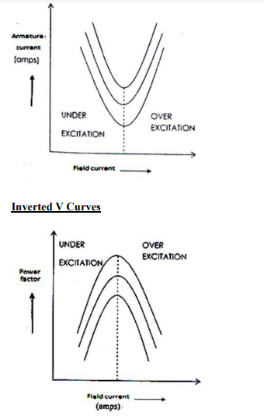
Results:
