4. Determination of direct axis and quadrature axis reactance of a salient pole alternator.
Exp no: Date

Aim: To determine the direct axis reactance Xd and quadrature axis reactance Xq by conducting a slip test on a salient pole synchronous machine.

Apparatus required:

S.no | Name of the Apparatus | Range | Type | Quantity
 | 3-phase auto transformer | 0-400 V | Variable | 1
 | Volt meter | (0-,300)V | MI | 1
 | Voltmeter | 0-300 V | MC | 1
 | Ammeter | 0-10 A | MI | 1
 | Ammeter | 0-2 A | MC | 1
 | Rheostat | 1000 ohms/1.2 A | Wire wound | 1
 | Connecting wires | 2.5sq.mm | Copper /Aluminum | Few

Name plate details:
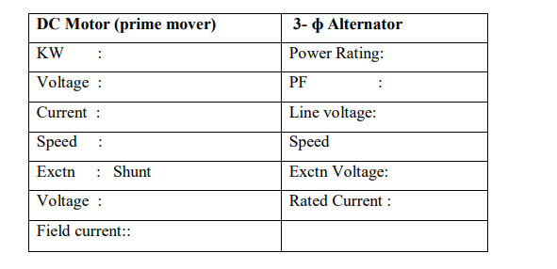
Precautions:
- 3-phase auto Transformer knob should be at zero position, before switching on the ac supply.
- When performing this test, the slip should be made as small as possible.
- During Slip test, it is observed that swing of the ammeter pointer is very wide, whereas the voltmeter has only small swing.

Procedure:
1. Connections are made as per the circuit diagram.
2. Initially set field regulator, 3-ɸ variac at minimum position and TPST switch open.
3. The DC motor is started slowly by sliding starter handle and it is run at a speed slightly less than the synchronous speed of the alternator.
4. Close the TPST switch.
5. With field winding left open, a positive sequence balanced voltages of reduced magnitude (around 25% of rated Value) and of rated frequency are impressed across the armature terminals.
6. The prime mover (DC motor) speed is adjusted till ammeter and voltmeters pointers swing slowly between maximum and minimum positions.
7. Under this condition, readings of maximum and minimum values of both ammeter and voltmeter are recorded
Theory:

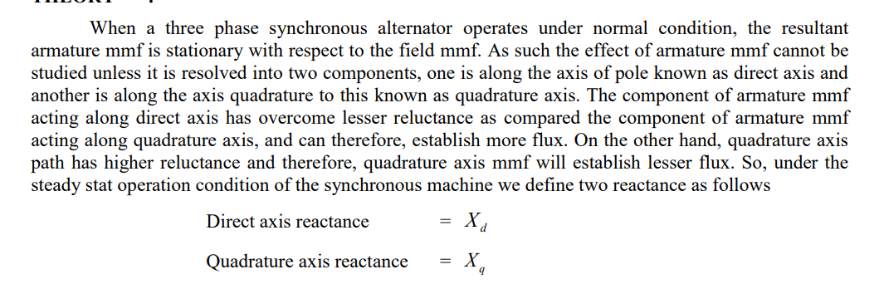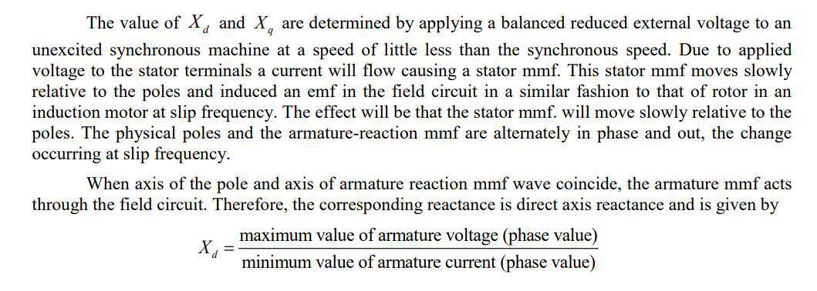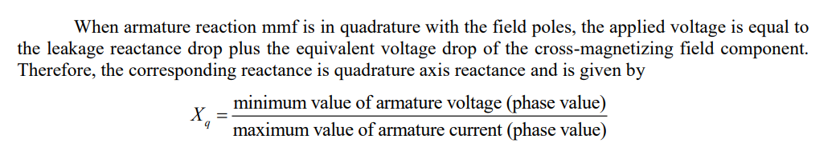

Circuit diagram:

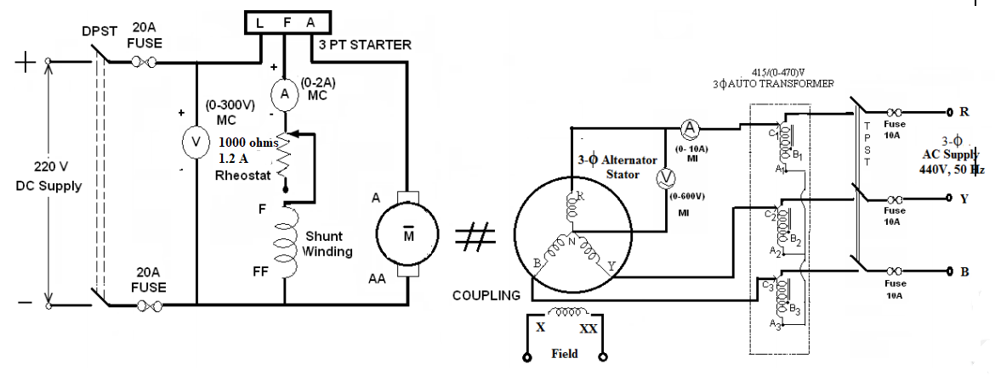

Observation Tables:
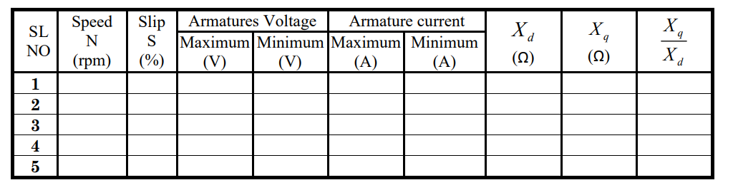
Formulae used:

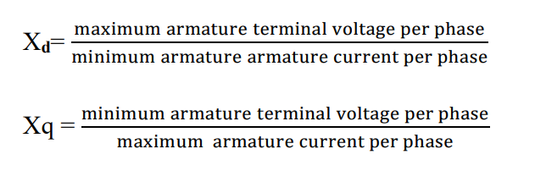
Model Calculations:

Results:

