5.Separation of losses in a 3-Ø induction motor
Exp no: Date

Aim: To separate the no load losses in a given three phase induction motor

Apparatus required:

S.no | Name of the Apparatus | Range | Type | Quantity
 | 3- phase Auto transformer | 0-400 V | Variable | 1
 | Ammeter | (0-5)A | MI | 1
 | Volt meter | (0-600)V | MI | 1
 | Wattmeter | 600 V, 10A | EDM | 1  1
 | Wattmeter | 600V,10A | EDM | 1  1
 | Connecting wires | 2.5sq.mm | Copper /Aluminum | Few

Name plate details:
Rated voltage =
Rated power =
Rated current =
Rated speed =
Precautions:
1. The motor should be at the no load condition while starting.
2. The 3Φ auto-transformer (variac) should be kept at initial zero position.

Procedure:
1. Connections are given as per the circuit diagram.
2. The 3Φ A.C supply is given by closing the TPST switch.
3. The induction motor is started gradually by applying voltage through the 3Φ autotransformer.
4. At rated voltage, power input Wo is measured by using wattmeter and no load current Io and voltage Vo are noted.
5. Voltage is gradually reduced till the motor continues to run.
6. For each voltage, readings of ammeter, voltmeter and wattmeter are noted.
7. Find the stator copper loss and constant loss by respective formulas.
8. Draw the suitable graph to find the mechanical loss.
9. Obtain the core loss by separating the mechanical loss from the constant loss.

Circuit diagram:
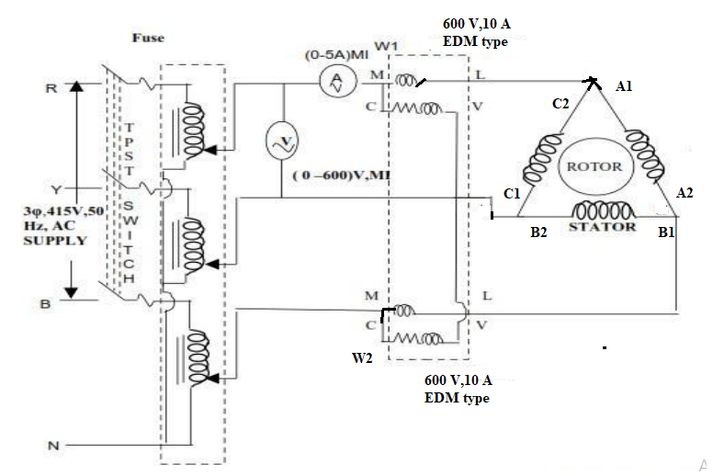

Observation Tables:

SI No | Volt meter reading(V)  Stator voltage | Ammeter reading (A)  No load current (Io) | W1 reading  ×MF | W2 reading  ×MF | Input power  W1+W2
1  2  3  4  5  6  7  8  9 | 400 V  350 V  300 V  250 V  200 V  150 V  100 V  50 V  0V

Formulae used:
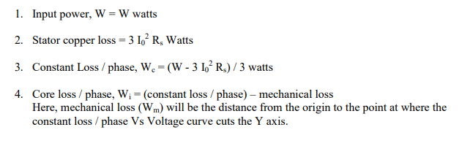
Model Calculations :

;Model Graphs:

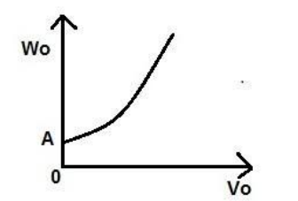

Results:

