6.Direct load test on a 1-Ø Induction motor
Exp no: Date

Aim: To conduct a direct load test on a 1-phase induction motor and to determine the torque, output power, efficiency, input power factor and slip of single-phase Induction motor for various load and plot the following curve.
i. Efficiency vs. output power.
ii. Torque vs. output power.
iii. Line current vs. output power.
iv. Power factor vs. output power.
v. Slip vs. output power
vi. Torque vs. slip.

Apparatus required:

S.no | Name of the Apparatus | Range | Type | Quantity
 | Ammeter | (0-10)A | MI | 1
 | Volt meter | (0-300)V | MI | 1
 | Watt meter | 300 V,10 A | EDM type | 1
 | Tachometer | (0-3000)rpm | Digital | 1
 | Connecting wires | 2.5sq.mm | Copper /Aluminum | Few

Name plate details:
Rated power =
Rated voltage=
Rated current =
Rated speed=

Precautions:
- Connections should be tight
- The motor should not be stopped under loaded condition
- There should be no load on the motor pulley while starting.

Procedure:
1. Connections are given as per the circuit diagram
2. The DPST switch is closed and the single phase supply is given to the motor.
3. By adjusting the autotransformer, the rated voltage is applied and the corresponding no load values of speed, spring balance and meter readings are noted down. If the wattmeter readings show negative deflection on no load, switch of the supply & Interchange the terminals of current coils (M & L) of the wattmeter. Now, again start the motor (follow above procedure for starting), take readings.
4. The procedure is repeated till rated current of the motor is reached.
5. The motor is unloaded; the auto transformer is brought to the minimum voltage position, and the DPST switch is opened.
6. The radius of the brake drum is measured.
Circuit diagram:
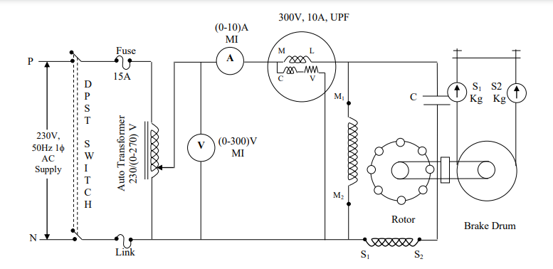
Observation Table
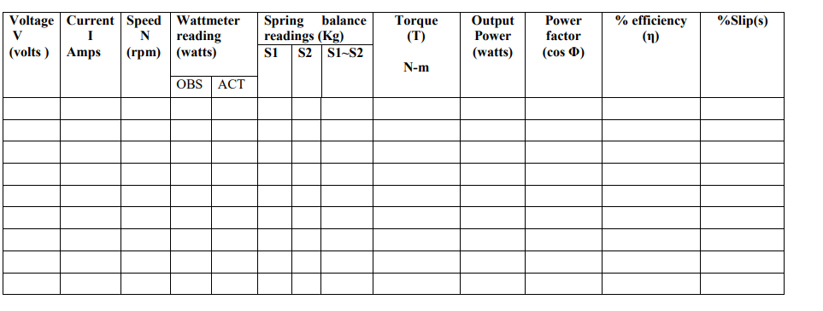
Formulae used:
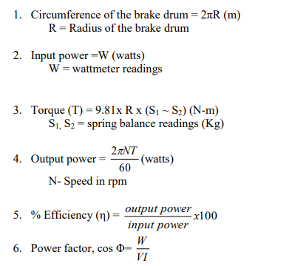

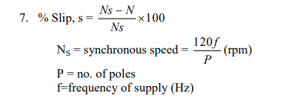

Model Calculations:

Model Graphs:
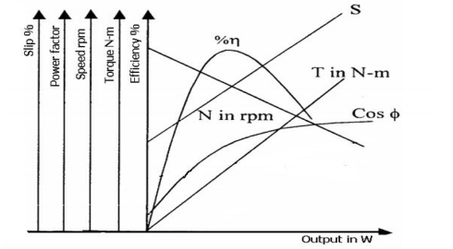

Result:

