7. Synchronization of alternator with bus-bar using dark/ bright lamp method
Exp no: Date
AIM: To synchronize the 3Φ alternator to the infinite bus bar.

Apparatus required:

S.no | Name of the Apparatus | Range | Type | Quantity
 | Ammeter | (0-2)A | MC | 1
 | Volt meter | (0-600)V | MI | 1
 | Rheostat | 1000 ohms/1.2 A | Wire wound | 1
 | Rheostat | 400 ohms/5A | Wire wound | 1
 | Synchronizing lamps | 230 V,15 A |  | 6
 | Connecting wires | 2.5sq.mm | Copper /Aluminum | Few

Name plate details:
Alternator
Rated power =
Rated voltage=
Rated current =
Rated speed=

DC Motor
Rated power =
Rated voltage=
Rated current =
Rated speed=

Procedure:

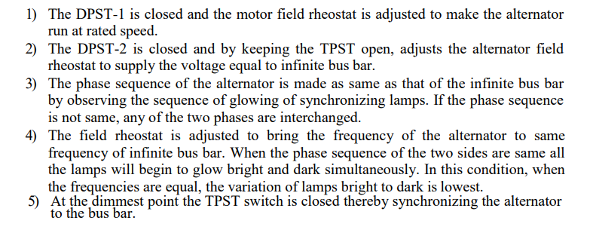

Circuit diagram

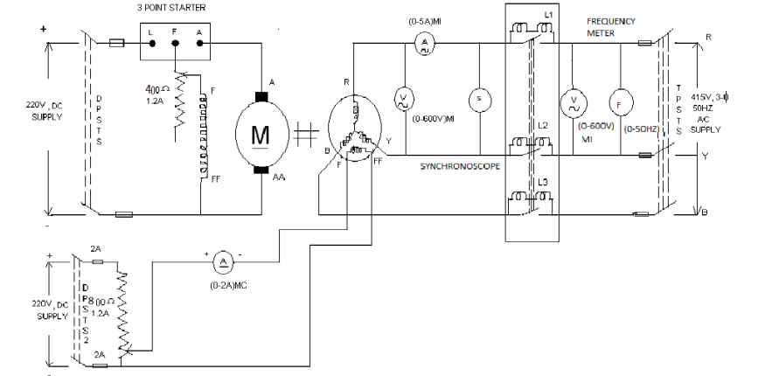

Result:

