8. Speed control of BLDC motor drive using MATLAB/ Simulink.
Exp No: Date :
Aim: to study the operation of BLDC drive and its torque speed characteristics.

Apparatus required:

200 W BLDC,
DC Source,
Controller Board
and DSO.

Precautions:
(a) check the load before switching on Motor. It should not be more than rated.
(b) speed feedback setting should be correct.
(c) Never rotate in reverse direction from forward before applying brake switch.

Procedure:

(1) Make the connections as per the wiring schedule in MATLAB
-Keep speed control pot P1 on BLDC-3 at Minimum position -Switch on SW1 on BLDC-1 panel.
(2) Vary the speed using the Pot P1 on BLDC-3 panel from min to max position.
(3) Connect channel-I of DSO to tage No. 5, 6,7 and 8 gnd (Test points on the BLDC-3 for PWM o/p). Set tme/div. knob on DSO at 10 us/div.and volts/div. knob at10V range.
(4) Higher speed will provide higher duty cycle for higher current PWM i.e. ON period. Therefore the in PWM pattern of the terminal voltage there will be a low voltage level for ON period and high level Voltage for the OFF time.
(5) Note the PWM pattern of terminal to terminal voltage in the middle portion for different
speeds.
(6) Also note the readings of the spring Load T1 and T2 ( in Kg) and calculate resultant torque (T1-T2)×R×9.8 in Nm. Note the speed for varying loads while DC voltage is always fixed ‘t ‘24 Vdc.
(7) For reversing the direction, first apply the brake switch ON and then change the direction by
tumbler switch and then turn of the brake switch.

Table: Commutation table for clockwise rotation.
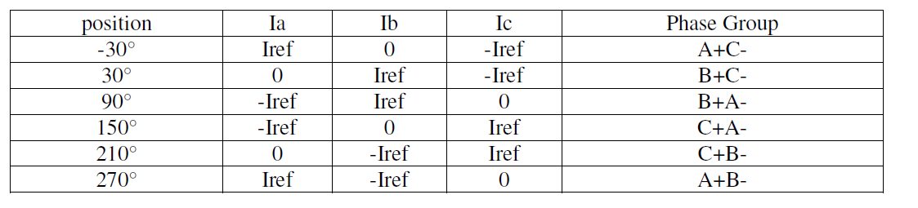

Theory

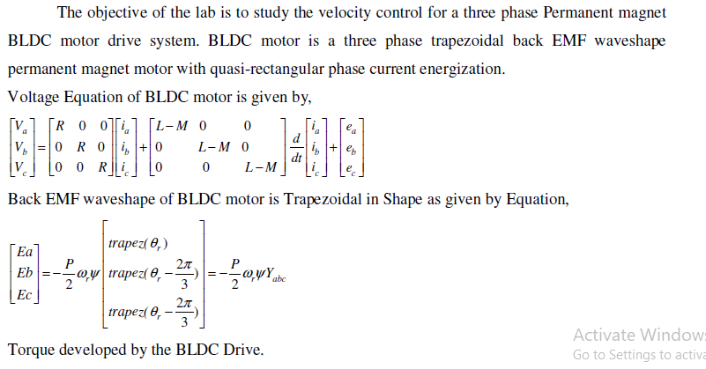
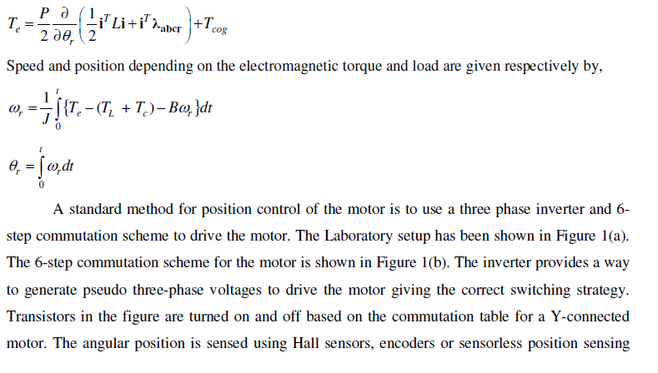
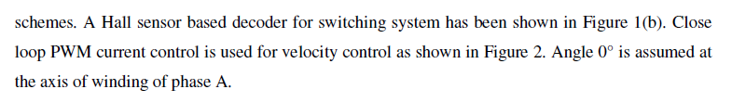

Simulink Circuits:

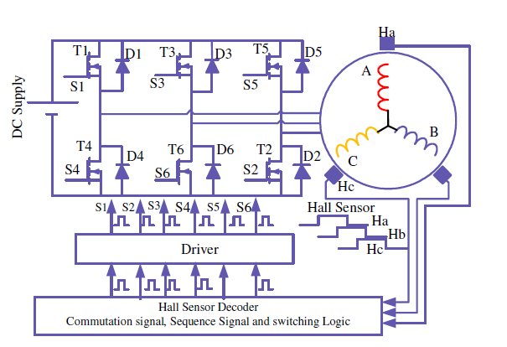

Fig 1 typical Hall sensor based 6-step commutation scheme for a three phase
motor BLDC drive

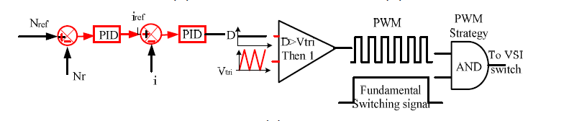
Fig 2 Close-loop triangular carrier based PWM current control for the speed control

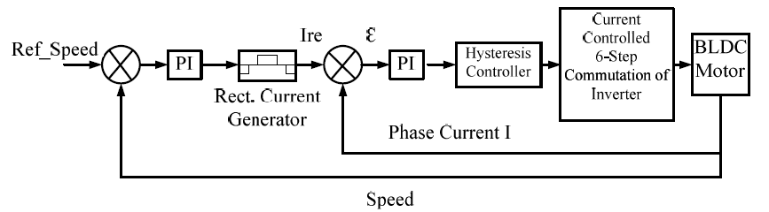

Fig 3. Closed loop Hysteresis controller based speed control.

Observation Tables:

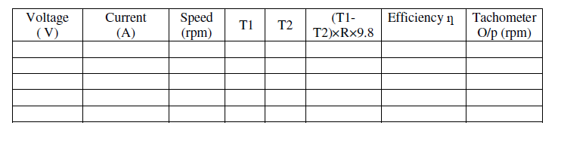
Various Plotted waveforms:

Result:

